Title/Headline
Name of the team leader, name of team members and of technical supervisor
Contact details of the team leader (Name, address, telephone, mail)

Summary
Here, you should explain your concept in only three sentences (maximum), so that outsiders know quickly what your concept is about. In principle it complies with an abstract.

Introduction
Motivation, background of your reaction(s), why do you choose this particular concept...These things can be explained here.

Concept
This part is certainly the most important one since here you present the main ideas of your ChemCar. Please remember, that a process flow diagram and a sketch of your car (if you already have one) are part of the description. If you already have first experiments, you can attach them to your concept description, too.

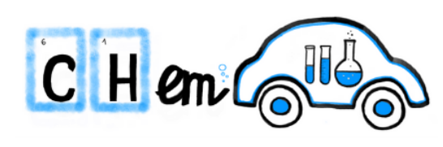
Figure 1: Formatting instruction for graphics.

Drive source
Here, you should mention a description of the drive source and explain how the energy is transformed into movement. You must list estimations of operating conditions (pressure and temperature) and used chemicals.

Braking mechanism
Very important: Your ChemCar should not only be driving, but has to stop in a defined distance. There are certainly several possibilities. Please have a look in the set of rules before deciding which braking mechanism you want to take for choosing a rule-consistent concept.

Outlook
Aspects such as the timetable, further-reaching ideas and strategies, fine tuning… in other words, everything that is yet undecided can be listed here.

List of references

Appendix

Contact data of safety officer:
Title: ...
Name: ...
First name: ...
Address: ...
...
Telephone: ...
Mail: ...

Contact data of team supervisor:
Title: ...
Name: ...
First name: ...
Address: ...
...
Telephone: ...
Mail: ...

Contact data of team leader:
Title: ...
Name: ...
First name: ...
Address: ...
...
Telephone: ...
Mail: ...

Table 1: Contact data of all persons responsible and participants
- | Name | Course of study | Semester | Telephone | E-Mail
Supervisor
Team leader
Member 2
Member 3
Member 4
Member 5

Table 2: List of chemicals
Chemical | Expected amount brought along to the competition | H and P statements

